

WORKDAY CAPITAL EQUIPMENT REQUISITION that includes a TRADE in (UWA)
A supplemental guide for creating and submitting requisitions in Workday for Capital Equipment in UW Academy
Workday Job Aid – Work Instructions

Purpose
The purpose of this guide is to help Requisitioners account for equipment that is purchased where a trade-in credit is received for traded in capital equipment.

Scenario: A new PCR system is being purchased. The PCR system has a total cost of $24,000.00.
The department has an outdated PCR system they are trading in for credit from the supplier. The supplier agrees to give the department a $6,000 trade in credit for the old PCR system.
Goals:
- Requisition the new equipment at $24,000 so that later an asset will be created that reflects the true value of the equipment.
- Capture the $6,000 trade in credit.
- Capture the physical tag# of the equipment being traded in, so that the Equipment Inventory Office can properly dispose of the equipment that is no longer at UW. Not doing this is an audit risk.

Create a Capital Asset Request (for Non-Catalog Capital Equipment)
(note: jump to step 5 if you don’t need help on creating a requisition you just need help on entering the goods lines correctly)

Steps
  - Type Create Requisition in the Search bar

1

  - Select the Create Requisition task from the search results
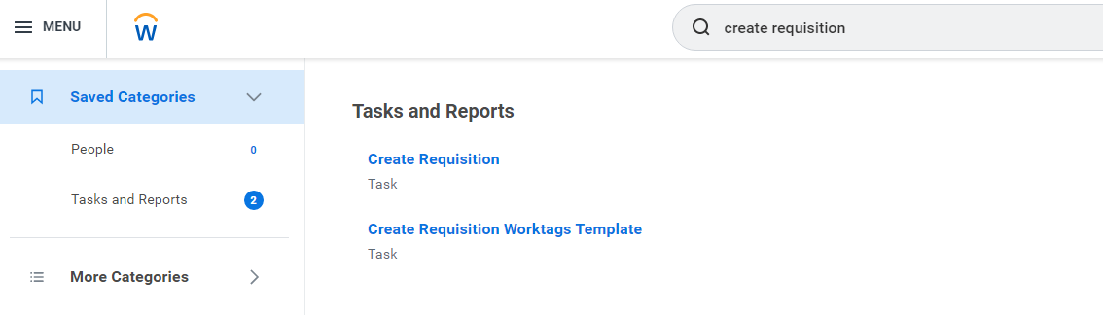
2
  - On the Create Requisition page, select Capital Asset Request from the available options. Then enter the Worktags for the purchase, the correct Deliver-To and Ship-To addresses, and other mandatory fields, then Click OK
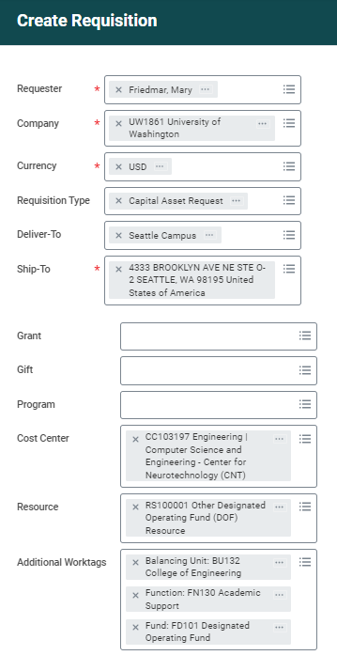
Note: If the requisition is on a Grant, the grant worktag will populate all other required worktags.
If the requisition is on a Cost Center, as shown here, entering the Cost Center will populate the Balancing Unit and Function worktags. You must then enter a Resource Worktag which will populate the Fund Worktag.
3

  - Select Request Non-Catalog Items
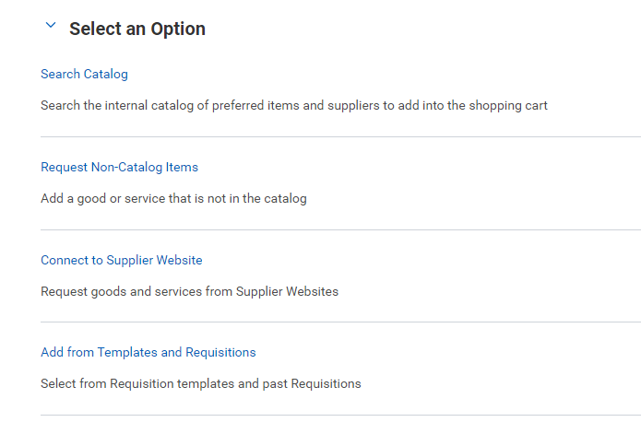
4
  - Complete the Goods Requests Details section for the new equipment and the trade in credit:
- Choose the correct Trackable Spend Category for the new equipment.
- add a 2nd line for the Trade-In using the Trade in Spend category (SC1256)
- Use the memo line to ADD the physical tag# of the equipment being traded in.
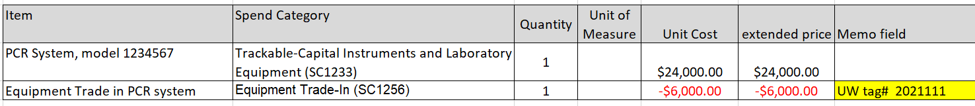

- Select Add to Cart

- Click the shopping cart

- Click Checkout
- Submit the requisition
</end>

